**HARSHTON JUNIOR SCHOOL – MBALE**

**TERM ONE HOLIDAY PACKAGE -2023**

**PRIMARY FOUR– MATHEMATICS**

.

**Pupil’s Name: …………………………………………………………….**

|  |  |  |
| --- | --- | --- |
| **Qn. No.** | **MARKS** | **EXRS No.** |
| **1 – 5** |  |  |
| **6 – 10** |  |  |
| **11 – 15** |  |  |
| **16 – 20** |  |  |
| **21 – 22** |  |  |
| **23 – 24** |  |  |
| **25 – 26** |  |  |
| **27 – 28** |  |  |
| **29 – 30** |  |  |
| **31 – 32** |  |  |
| **TOTAL** |  |  |

**TURN OVER**

**Read the following instructions carefully:**

1. This paper has **two** sections **A** and **B**

Section A has **20** questions and Section **B** has **12** questions. The paper has 15 printed pages.

1. All the working for both sections A and B must be shown in the spaces provided.
2. All working must be done using a blue or black ball point pen or ink. Any work done in pencil other than graphs and diagrams will **not** be marked.
3. **No calculators** are allowed in the examination room.
4. Unnecessary changes of work may lead to **loss** of marks.
5. Any **handwriting** that cannot easily be read may lead to loss of marks.
6. Do not fill anything in the boxes indicated: “**For examiners’ Use only”** and those inside the questions paper.

`

**SECTION A (40 MARKS)**

|  |  |  |  |
| --- | --- | --- | --- |
| 1. | Subtract 8 6  - 2 4 | 2. | Write 25 in Roman numerals. |
| 3. | What number has been expanded to give  500 + 30 + 60? | 4. | Name the shape below. |
| 5. | Write 2 4 6 in words. | 6. | List down the first four odd numbers. |
| 7. | Find the value of 2 in the number 2 6 5. | 8. | In a shop, one book costs sh. 400. What is the cost of four similar books? |
| 9. | If R= and    T=  Describe set R and set T. | 10. | If =10 pots, how many pots are shown? |
| 11. | What number is shown on the abacus?  H T O | 12. | Shade PuQ  P Q |
| 13. | Add:  + | 14. | Find the total distance around the figure below.  9cm |
| 15. | Find the next number in the sequence.  0, 5, 10, 15, 20, ________ | 16. | What time is shown on the clock face?  _____________________________ |
| 17. | Change 8m to cm. | 18. | Find the unshaded fraction.   |  |  |  |  | | --- | --- | --- | --- | |  |  |  |  | |  |  |  |  |     __________________ |
| 19. | Share 18 books among 3 children. | 20. | Work out: ÷ 4 = 3 |

**SECTION B (60 MARKS)**

1. Given that K= {0, 1, 2, 3, 4, 5,} and L = {1, 3, 5, 7, 9}

Represent set K and L on the venn diagram below.

K L

What is KnL? **(3 marks)**

How many members are in set K and L? **(2 marks)**

1. Work out the area in each of the figures below.
2. **(2 marks)**

**8cm**

**10cm**

**5cm**

1. **(2 marks)**
2. Complete the table correctly.

|  |  |  |  |  |  |  |
| --- | --- | --- | --- | --- | --- | --- |
| **Weeks** | 1 | _____ | 3 | ______ | 6 | _____ |
| **Days** | 7 | 14 | _______ | 28 | ______ | 35 |

(5 marks)

1. **Complete the table below correctly.**  (5 marks)

|  |  |  |  |
| --- | --- | --- | --- |
| **Number** | **Place values** |  | **Values** |
| 6 4 7 2 9 | Ones  Tens  Thousands  Ten thousands | 9x1  2x10  7x100  _________  6 x 10,000 | 9  __________  700  __________  __________ |

1. **Draw the following shapes.** (6 marks)

|  |  |  |
| --- | --- | --- |
|  |  |  |
| Rectangle | kite | cuboid |

1. Find the missing numbers. (6 marks)
2. + 10 = 15
3. x 4 = 12
4. 8 – = 3
5. 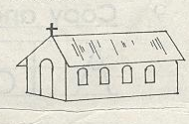**Below is Enwaku’s journey. Study it carefully and use it to answer the questions that follow.**



12 km

Home

Church

7km

10km

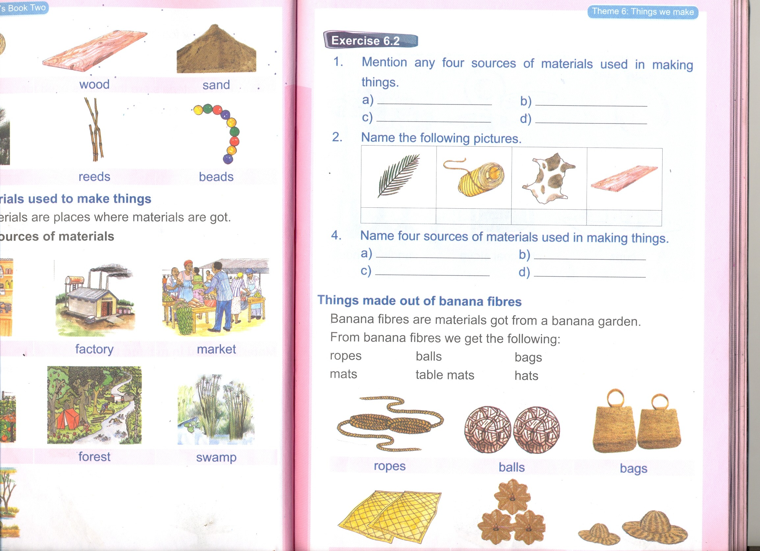

1. What distance does Enwaku cover from home to the church?

(1 mark)

1. What distance did he walk from the church to the market then home?

(2 marks)

1. Find the total distance that he covered for the whole journey.

(2 marks)

1. In a P.4 class there are 26 boys and 72 girls.
2. How many children are in P.4 altogether? (2 marks)
3. How many more girls than boys are in P.4? (2 marks)
4. Study the price list below.

|  |  |
| --- | --- |
| **Item** | **Unit Price** |
| A book | Sh. 500 |
| A pen | Sh. 400 |
| A pencil | Sh. 200 |
| A set | Sh. 2500 |

1. What is the most expansive item? (1 mark)
2. How much will one pay for 3 books? (2 marks)
3. If peter bought each item above how much did he pay altogether?
4. Write either <, > or = to complete the statements.

IX _________________ XI (2 marks)

1 metre _________________ 100cm (2 marks)

 _________________  (2 marks)

1. a) Add 3 + 5 using a number line. (2 marks)

0 1 2 3 4 5 6 7 8 9 10

b) Subtract 6 – 2 using a number line. (2 marks)

0 1 2 3 4 5 6 7 8 9 10

1. **The graph below shows the number of books that some P.4 pupils have. Use it to answer the questions that follow.**

80

**Number of books**

|  |
| --- |
| 70 |
| 60 |
| 50 |
| 40 |
| 30 |
| 20 |
| 10 |
| 0  **Tom Sam Alex Tom Nancy** |

1. Who got the least number of books? (1 mark)
2. How many books did Sam and Nancy have altogether? (1 mark)
3. Who never got books? (1 mark)
4. Find the total number of books got by the pupils altogether? (2 marks)

**HARSHTON JUNIOR SCHOOL – MBALE**

**TERM ONE HOLIDAY PACKAGE -2023**

**PRIMARY FOUR INTEGRATED SCIENCE**

**Pupil’s Name: ……………………………………………………….**

**Read the following instructions carefully:**

1. This paper has two sections A and B

Section A has 40 questions and section B has 15 questions.

1. All working must be done using a blue or black ball point pen or ink. Any work done in pencil other than graphs and diagrams will **not** be marked.
2. Unnecessary changes of work may lead to **loss** of marks.
3. Any **handwriting** that cannot easily be read may lead to loss of marks.
4. Do not fill anything in the boxes indicated: “**For examiners’ Use only”** and those inside the questions paper.

|  |  |  |
| --- | --- | --- |
| **Qn. No.** | **MARKS** | **EXRS No.** |
| **1 – 10** |  |  |
| **11 – 20** |  |  |
| **21 – 30** |  |  |
| **31 – 40** |  |  |
| **41 – 50** |  |  |
| **51 - 52** |  |  |
| **53- 54** |  |  |
| **55** |  |  |
| **TOTAL** |  |  |

**Turn over**

**SECTION A (40 MARKS)**

1. State **one** component of environment.

……………………………………………………………………………………………………………………...…………

1. How is sun useful to man?

……………………………………………………………………………………………………………………...…………

1. Why is loam soil good for crop growing?

……………………………………………………………………………………………………………………...…………

1. Identify the component of air that supports burning.

……………………………………………………………………………………………………………………...…………

1. Mention any **one** animal kept in aquarium.

……………………………………………………………………………………………………………………...………

1. In the space provided below. Draw a garden tool used for watering seedlings.
2. What is wind?

……………………………………………………………………………………………………………………...…………

……………………………………………………………………………………………………………………...…………

1. Write down any one PIASCY message.

……………………………………………………………………………………………………………………...…………

1. Name the type of clouds that gives rain.

……………………………………………………………………………………………………………………...…………

**The diagram below shows a type of germination. Use it to answer questions 10 and 11.**

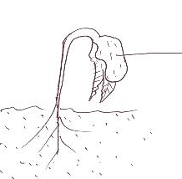

Cotyledon

1. Identify the type of germination shown above.

……………………………………………………………………………………………………………………...…………

1. Write down any **one** plant that undergoes the type of germination above.

……………………………………………………………………………………………………………………...…………

1. State **one** harmful insect to man.

……………………………………………………………………………………………………………………...…………

1. Name the best method of controlling soil erosion in the school compound?

……………………………………………………………………………………………………………………...…………

1. Why is a warm considered to be a living thing?

……………………………………………………………………………………………………………………...…………

1. Which is the best method of controlling soil erosion in the school compound?

……………………………………………………………………………………………………………………...…………

1. Why is a fire extinguisher important at school?

……………………………………………………………………………………………………………………...…………

1. State any **one** process involved in rain formation.

……………………………………………………………………………………………………………………...…………

1. Mention any **one** product got from cows.

……………………………………………………………………………………………………………………...…………

1. Mention **one** item used for giving first aid.

……………………………………………………………………………………………………………………...…………

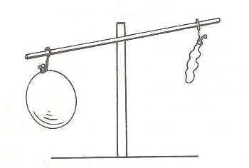**The diagram below shows a property of air. Use it to answer question 19.**

1. What property of air is shown above?

……………………………………………………………………………………………………………………...…………

1. Why do farmers rear domestic animals?

……………………………………………………………………………………………………………………...…………

1. Which part of an Irish potato is eaten as food?

……………………………………………………………………………………………………………………...…………

1. How is electricity important at home?

……………………………………………………………………………………………………………………...…………

1. What are ceramics

……………………………………………………………………………………………………………………...………………………………………………………………………………………………………………………………...…………

1. Why is sugar used for making oral rehydration salt?

……………………………………………………………………………………………………………………...…………

1. Mention **one** domestic bird kept at home.

……………………………………………………………………………………………………………………...…………

1. In which way is malaria controlled at home.

……………………………………………………………………………………………………………………...…………

1. State **one** characteristics of insects

……………………………………………………………………………………………………………………...…………

1. How are seedlings cared for in a nursery bed?

……………………………………………………………………………………………………………………...…………

1. Write down any **one** way in which some insects are harmful to man?

……………………………………………………………………………………………………………………...…………

**The following are vegetable crops;**

Dodo

Cabbage

Spinach

Nakati

Tomatoes.

1. Which **one** of the above vegetable crops stores its food in the leaves?

……………………………………………………………………………………………………………………...…………

1. State any **one** way of promoting cleanliness in a classroom.

……………………………………………………………………………………………………………………...…………

1. Why is it bad to share a house with domestic animals?

……………………………………………………………………………………………………………………...…………

1. Mention **one** function of leaves to a plant.

……………………………………………………………………………………………………………………...…………

1. How is sunny weather managed by people?

……………………………………………………………………………………………………………………...…………

1. Mention any **one** immunizable disease immunized to infants.

……………………………………………………………………………………………………………………...…………

1. State any **one** agent of soil erosion.

……………………………………………………………………………………………………………………...…………

1. Give the main natural source of light and heat.

……………………………………………………………………………………………………………………...…………

1. Give **one** reason why people eat food.

……………………………………………………………………………………………………………………...…………

1. Mention any **one** importance of giving first Aid to casualty.

……………………………………………………………………………………………………………………...…………

**SECTION B (60 MARKS)**

1. a) What is meant by the term a germ?

……………………………………………………………………………………………………………………...………………………………………………………………………………………………………………………………...…………

1. Give **one** example of a germ.

……………………………………………………………………………………………………………………...………

1. State any **two** diseases caused due to poor hygiene.
2. ……………………………………………………………………………………………………………………..
3. .……………………………………………………………………………………………………………………
4. **Match the garden tools with their uses.**

**GARDEN TOOL USE**

Panga digging

Slasher cutting small trees.

Axe cutting tall grass.

Hoe cutting big trees.

1. a) Write down any **two** way roots are useful to man.
2. ……………………………………………………………………………………………………………………...…
3. …………………………………………………………………………………………………………………………
4. Mention **one** example of a root tuber.

……………………………………………………………………………………………………………………...………

1. Name the food value got from an onion.

……………………………………………………………………………………………………………………...………

1. a) **Draw and name any two items used for promoting personal hygiene.**

|  |  |
| --- | --- |
|  |  |
|  |  |

1. Mention **two** reasons for promoting sanitation.
2. ……………………………………………………………………………………………………………………..
3. .……………………………………………………………………………………………………………………
4. a) Complete the larva stage of the following insects.
5. Housefly: ……………………………………………………………………………………………………….
6. Butterfly: ………………………………………………………………………………………………………
7. What type of metamorphosis does a cockroach undergo?

……………………………………………………………………………………………………………………...………

1. Why do insects move from one place to another?

……………………………………………………………………………………………………………………...………

1. a) Germination is the development of a seed into a seedling. Mention any **two** types of germination.
2. ……………………………………………………………………………………………………………………...…
3. …………………………………………………………………………………………………………………………
4. State any **two** conditions necessary for germination to take place.
5. ……………………………………………………………………………………………………………………...…
6. …………………………………………………………………………………………………………………………
7. a) State any **two** components of environment.
8. ……………………………………………………………………………………………………………………...…
9. …………………………………………………………………………………………………………………………
10. State any **one** difference between plants and animals.

……………………………………………………………………………………………………………………...………

1. Give the similarity between plants and animals.

……………………………………………………………………………………………………………………...………

1. a) Mention **one** source of water.

……………………………………………………………………………………………………………………...…………

1. Write down any **two** uses of water at home.
2. ……………………………………………………………………………………………………………………..
3. .……………………………………………………………………………………………………………………
4. What instrument is used for measuring rainfall?

……………………………………………………………………………………………………………………...………

1. a) Writing down **two** places for storing harvested crops.
2. ……………………………………………………………………………………………………………………...…
3. …………………………………………………………………………………………………………………………
4. Why are granaries made with rat guards on the poles?

……………………………………………………………………………………………………………………...………

1. Mention any **one** condition considered before storing harvested crops.

……………………………………………………………………………………………………………………...………

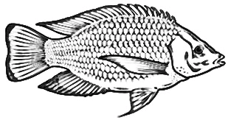

a

C

b

1. a) Name parts marked “a” and “b”.
2. a: ……………………………………………………………………………………………………………………
3. b: …………………………………………………………………………………………………………………..
4. What is the use of part marked **“a”.**

……………………………………………………………………………………………………………………...………

1. Name the part that protects the gills of the above animal.

……………………………………………………………………………………………………………………...………

1. Write down any **four** ways of preserving food.
2. ……………………………………………………………………………………………………………………...…
3. …………………………………………………………………………………………………………………………
4. …...……………………………………………………………………………………………………………………
5. …………...……………………………………………………………………………………………………………

**An experiment about soil components was done by a P.4 learner as shown below. Use it to answer questions 52**

Bubble of air

Water

Lump of soil

1. a) What is the experiment about?

……………………………………………………………………………………………………………………...………

1. What was seen after the child doing the experiment?

……………………………………………………………………………………………………………………...………

1. Apart from the above component of soil shown. Name any other two components of soil.

……………………………………………………………………………………………………………………...………

1. a) Name **two** examples of changes in the environment.
2. ……………………………………………………………………………………………………………………...…
3. ………………………………………………………………………………………………………………………….
4. Give the examples of natural changes in environment.

……………………………………………………………………………………………………………………...………

**The table below shows records of the crop activities. Use it to answer question 54.**

|  |  |
| --- | --- |
| **DATE** | **ACTIVITY** |
| 6/07/2019 | Planting tomato seeds in a nursery bed. |
| 28/07/2019 | Transplanting the seedlings. |
| 18/08/2019 | Weeding |
| 20/08/2019 | Mulching tomatoes. |
| 23/08/2019 | Spraying of tomatoes. |
| 15/09/2019 | Harvesting of tomatoes. |

1. a) Identify the activity that prevents pests on the tomatoes.

……………………………………………………………………………………………………………………...………

1. In which month of the year was mulching done?

……………………………………………………………………………………………………………………...………

1. Why is it good for a farmer to weed the tomatoes?

……………………………………………………………………………………………………………………...………

1. How do we call the activity of removing ready tomatoes in the garden?

……………………………………………………………………………………………………………………...………

1. **The pie chart below shows percentage composition of air in the atmosphere. Use it to answer questions 55.**

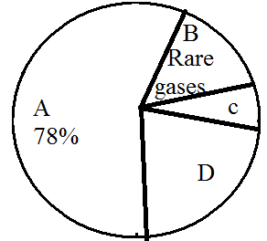

1. Identify the gas with the highest percentage in the atmosphere.

……………………………………………………………………………………………………………………...………

1. How is gas marked “D” important to the following organisms;
2. Plants: ………………………………………………………………………………………………………
3. Animals: ………………………………………………………………………………………………….
4. What is the percentage of gas marked “C”

……………………………………………………………………………………………………………………...………

**HARSHTON JUNIOR SCHOOL – MBALE**

**TERM ONE HOLIDAY PACKAGE -2023**

**PRIMARY FIVE MATHEMATICS**

**Pupil’s Name: …………………………………………………………….**

|  |  |  |
| --- | --- | --- |
| **Qn. No.** | **MARKS** | **EXRS No.** |
| **1 – 5** |  |  |
| **6 – 10** |  |  |
| **11 – 15** |  |  |
| **16 – 20** |  |  |
| **21 – 22** |  |  |
| **23 – 24** |  |  |
| **25 – 26** |  |  |
| **27 – 28** |  |  |
| **29 – 30** |  |  |
| **31 – 32** |  |  |
| **TOTAL** |  |  |

**TURN OVER**

**Read the following instructions carefully:**

1. This paper has **two** sections **A** and **B**

Section A has **20** questions and Section **B** has **12** questions. The paper has 15 printed pages.

1. All the working for both sections A and B must be shown in the spaces provided.
2. All working must be done using a blue or black ball point pen or ink. Any work done in pencil other than graphs and diagrams will **not** be marked.
3. **No calculators** are allowed in the examination room.
4. Unnecessary changes of work may lead to **loss** of marks.
5. Any **handwriting** that cannot easily be read may lead to loss of marks.
6. Do not fill anything in the boxes indicated: “**For examiners’ Use only”** and those inside the questions paper.

`

**SECTION A (40 MARKS)**

|  |  |  |  |
| --- | --- | --- | --- |
| 1. | Workout 4 3  + 1 6 | 2. | Change 15 to Roman numerals. |
| 3. | Workout the missing number in the box.  X 6 = 36 | 4. | Describe the shaded region in the venn diagram below.  Q P |
| 5. | Show 6 o’clock on the clock face below. | 6. | Nammwongo bought a book at shs. 500. How much did she pay for 3 similar books? |
| 7. | Workout:  + | 8. | If represents 6 balls, how many pictures of balls will represent 18 balls? |
| 9. | Find the next number in the sequences.  1, 3, 5, 7, _________ | 10. | Share 24 mangoes among 3 children. |
| 11. | Name the shape below. | 12. | Change 4 metres to cm. |
| 13. | How many weeks are in 21 days? | 14. | Find the LCM of 6 and 4. |
| 15. | Workout the area of the figure below.   |  |  |  |  | | --- | --- | --- | --- | |  |  |  |  | |  |  |  |  | |  |  |  |  | | 16. | How many factors has 12. |
| 17. | Write the shaded fraction. | 18. | Expand 7043 using values. |
| 19. | A man had shs. 5000, he bought sugar for shs. 3200. How much money did he remain with? | 20. | If set P = { 2, 3, 4, 5}  Q = { 0, 2, 4, 6}  Find PuQ |

**SECTION B (60 MARKS)**

1. Given that A = { 2, 4, 6, 8, 10} and B ={1, 2, 3, 4, 5, 6}
2. Represent the above information on a Venn diagram.

A B (3 mks)

1. Find
2. AnB (1 mk)
3. AuB (1 mk)
4. a) Expand 3 4 6 using place values. (2 mks)
5. Find the value of 6 hundreds. (2 mks)
6. Workout the single number whose expanded form is?

2 thousands + 3 tens + 7 ones (2 mks)

1. John is 6 years older than Sarah who is 18 years.
2. How old is John? (2 mks)
3. Find the total age. (2 mks)
4. How old will Sarah be in 2 years time? (1 mk)
5. a) Workout the perimeter of the figure. (2 mks)

8cm

6cm

4cm

1. Calculate the area of the square below. (2 mks)

8m

1. Subtract 23 from 50. (1 mk)
2. Study the shopping list below and answer questions that follow.

Sugar shs. 3200

Rice shs. 2800

Soap shs. 3000

Cooking oil shs. 4600

1. How much will Opoo pay if he buys a kilo of sugar and a litre of cooking oil? (2 mks)
2. If Suzan had shs. 5000 and bought a bar of soap. How much did she get as her change. (2 mks)
3. Complete the table.

|  |  |  |  |  |  |  |
| --- | --- | --- | --- | --- | --- | --- |
| **Weeks** | 1 | _____ | 3 | ______ | 5 | ______ |
| **Days** | 7 | 14 | ______ | 28 | _____ | 42 |

1. Study the geometrical figure below and use it to answer questions that follow.

4cm

5cm

6cm

1. Find the number of faces. (1 mk)
2. Find the area of the shaded part. (2 mks)
3. Calculate the volume of the figure. (2 mks)
4. Given 6, 2, 5.
5. Form the smallest number using the digits above. (1 mk)
6. Form the largest number. (1 mk)
7. Find the sum of the smallest and the largest number formed.(2 mks)
8. a) Change  into a mixed fraction. (2 mks)
9. Subtract  - = (2 mks)
10. Add: 2 + 2= (2 mks)
11. Workout:
12. **Hours Mins (2 mks)**

4 20

+ 3 30

1. **Wks Days (2 mks)**

5 3

* + 2 6

1. How many days are in the months of January? (1 mk)
2. Mbabazi scored the following marks in the end of the year exams.

English 70

Maths 83

SST 92

Science 94

1. In which subject did she get the highest mark? (1 mk)
2. Find the difference between the highest and the lowest mark.
3. Find the total marks in all the subjects. (2 mks)
4. Study the figure below and use it to answer questions that follow.

A

B

D

F

C

E

1. Name the line marked. (1 mk @)
2. C D: ____________________________________
3. A B: ____________________________________
4. E F: ____________________________________
5. Find the length of line mark CD if CB is 7cm. (2 mks)

**HARSHTON JUNIOR SCHOOL – MBALE**

**PRIMARY FOUR – MID TERM ONE EXAMINATIONS**

**SOCIAL STUDIES 2020**

**DURATION: 2 HOURS 15 MINUTES.**

**Pupil’s Name: ……………………………………………………….**

**District Name:………………………………………………………...**

**Read the following instructions carefully:**

1. This paper has two sections A and B

Section A has 40 questions and section B has 15 questions.

1. All working must be done using a blue or black ball point pen or ink. Any work done in pencil other than graphs and diagrams will **not** be marked.
2. Unnecessary changes of work may lead to **loss** of marks.
3. Any **handwriting** that cannot easily be read may lead to loss of marks.
4. Do not fill anything in the boxes indicated: “**For examiners’ Use only”** and those inside the questions paper.

|  |  |  |
| --- | --- | --- |
| **Qn. No.** | **MARKS** | **EXRS No.** |
| **1 – 10** |  |  |
| **11 – 20** |  |  |
| **21 – 30** |  |  |
| **31 – 40** |  |  |
| **41 – 50** |  |  |
| **51 - 52** |  |  |
| **53- 54** |  |  |
| **55** |  |  |
| **TOTAL** |  |  |

**Turn over**

**SECTION A (40 MARKS)**

* + - 1. Give any **one** means of transport used on roads.

……………………………………………………………………………………………………………………………

* + - 1. Mention **one** group of people who need a compass in their daily work.

……………………………………………………………………………………………………………………………

* + - 1. Name **one** colour of the Uganda flag.

……………………………………………………………………………………………………………………………

* + - 1. Write **one** source of water in our community?

……………………………………………………………………………………………………………………………

* + - 1. What are physical features?

……………………………………………………………………………………………………………………………

* + - 1. Name the drawn map symbol

……………………………………………………………………………………………………………………………

* + - 1. How do we call people who keep laws and order?

……………………………………………………………………………………………………………………………

* + - 1. Mention **one** place where we go for treatment when we fall sick.

……………………………………………………………………………………………………………………………

* + - 1. Name **one** thing that can be made from animal skins and hides in your district.

……………………………………………………………………………………………………………………………

* + - 1. Name **one** place where people keep their money safe.

……………………………………………………………………………………………………………………………

* + - 1. Write **one** example of an economic activity?

……………………………………………………………………………………………………………………………

* + - 1. State **one** crop that grows well in swampy areas.

……………………………………………………………………………………………………………………………

* + - 1. State **one** way of locating our school.

……………………………………………………………………………………………………………………………

* + - 1. Which physical feature is found between two closed hills or mountains?

……………………………………………………………………………………………………………………………

* + - 1. Mention **one** method of preserving fish.

……………………………………………………………………………………………………………………………

* + - 1. State **one** use of electricity at home.

……………………………………………………………………………………………………………………………

* + - 1. Write down **one** importance of school uniform to school children.

……………………………………………………………………………………………………………………………

* + - 1. Write LC in full.

……………………………………………………………………………………………………………………………

* + - 1. What type of transport uses a ship?

……………………………………………………………………………………………………………………………

* + - 1. How important are cooks in our school.

……………………………………………………………………………………………………………………………

* + - 1. Mention any **one** quality of a good map.

……………………………………………………………………………………………………………………………

* + - 1. What product do we get from sugar cane?

……………………………………………………………………………………………………………………………

* + - 1. Why do we need a farmer?

……………………………………………………………………………………………………………………………

* + - 1. Mention any **one** cardinal point of compass.

……………………………………………………………………………………………………………………………

* + - 1. Name any **one** television station in Uganda.

……………………………………………………………………………………………………………………………

* + - 1. Which direction does the sun set.

……………………………………………………………………………………………………………………………

* + - 1. Mention **one** commercial bank in Uganda.

……………………………………………………………………………………………………………………………

* + - 1. Which economic activity do people do around lakes?

……………………………………………………………………………………………………………………………

* + - 1. Mention **one** food crop grown in our district.

……………………………………………………………………………………………………………………………

* + - 1. Mention **one** item made out of sisal.

……………………………………………………………………………………………………………………………

* + - 1. Write **one** responsibility of children at home.

……………………………………………………………………………………………………………………………

* + - 1. **EITHER:**

Who was the mother of Jesus Christ?

……………………………………………………………………………………………………………………………

**OR:**

Who was the mother of Prophet Muhammad?

……………………………………………………………………………………………………………………………

* + - 1. **EITHER:**

How important is every Sunday to Christians.

……………………………………………………………………………………………………………………………

**OR:**

Give the importance of every Friday to Muslims.

……………………………………………………………………………………………………………………………

* + - 1. **EITHER:**

Write C.R.E in full.

……………………………………………………………………………………………………………………………

**OR:**

What is I.R.E in full?

……………………………………………………………………………………………………………………………

* + - 1. **EITHER:**

Why do Christians pray?

……………………………………………………………………………………………………………………………

**OR**

Why do Muslims pray?

……………………………………………………………………………………………………………………………

* + - 1. **EITHER:**

Whom did God give the Ten Commandments?

……………………………………………………………………………………………………………………………

**OR:**

Whom did Allah give the Holy Qur’an?

……………………………………………………………………………………………………………………………

* + - 1. **EITHER:**

State **one** symbol of a Christian family.

……………………………………………………………………………………………………………………………

**OR:**

Mention **one** symbol of a Muslim family.

……………………………………………………………………………………………………………………………

* + - 1. **EITHER:**

Name the Holy book for Christians.

……………………………………………………………………………………………………………………………

**OR:**

Name the Holy book for Muslims.

……………………………………………………………………………………………………………………………

* + - 1. **EITHER:**

Mention one good thing a child should do to elders.

……………………………………………………………………………………………………………………………

**OR:**

What should a good child do to elders?

……………………………………………………………………………………………………………………………

* + - 1. **BOTH:**

Give **one** example of people who need help.

……………………………………………………………………………………………………………………………

**SECTION B (60 MARKS).**

* + - 1. a) Name the longest river in Uganda.

……………………………………………………………………………………………………………………………

1. Mention **two** ways rivers are important to people.
2. ……………………………………………………………………………………………………………
3. ……………………………………………………………………………………………………………
4. Why is it dangerous for people to stay near rivers?

………………………………………………………………………………………………………………………

* + - 1. a) **Match the type of transport to their means correctly.**

Road transport Boat

Railway transport Train

Water transport Motorcycle.

Air transport Aeroplane.

Road transport: ………………………………………….……………………………………

Railway transport: ………………………………………………………………………………

Water transport: ………………………………………………………………………………

Air transport: ………………………………………………………………………………

* + - 1. a) Mention **two** types of leaders.

1. …………………………………………………………………………………………………………………
2. …………………………………………………………………………………………………………………
3. Give any **two** examples of leaders found at school.
4. …………………………………………………………………………………………………………………
5. …………………………………………………………………………………………………………………
   * + 1. a) Name any **two** needs of a farmer.
6. …………………………………………………………………………………………………………………
7. …………………………………………………………………………………………………………………
8. Give any **one** importance of rainfall to a farmer.

……………………………………………………………………………………………………………………………

1. How does too much sunshine affect a farmer?

……………………………………………………………………………………………………………………………

* + - 1. a) State **two** things used to keep our classroom clean.

1. …………………………………………………………………………………………………………………
2. …………………………………………………………………………………………………………………
3. Give two roles of class monitors.
4. …………………………………………………………………………………………………………………
5. …………………………………………………………………………………………………………………
   * + 1. a) What is the main work of Uganda police force?

……………………………………………………………………………………………………………………………

1. Which group of police the controls vehicles that move on roads?

………………………………………………………………………………………………………………………

1. What **two** bad things make people to be arrested by the police?
2. ……………………………………………………………………………………………………………
3. ……………………………………………………………………………………………………………
   * + 1. a) What are children’s rights?

…………………………………………………………………………………………………………………………………………………………………………………………………………………………………………………………

1. Give **two** examples of children’s rights.
2. ……………………………………………………………………………………………………………
3. ……………………………………………………………………………………………………………
4. How have children’s rights been abused?

………………………………………………………………………………………………………………………

* + - 1. a) Name the point of a compass marked Y.

Y

………………………………………………………

1. What compass point is between North and East?

………………………………………………………………………………………………………………………

1. Where does a compass needle point when it’s at rest?

………………………………………………………………………………………………………………………

1. How is useful is a compass to a ship captain.

………………………………………………………………………………………………………………………

* + - 1. a) Name the following map symbols.

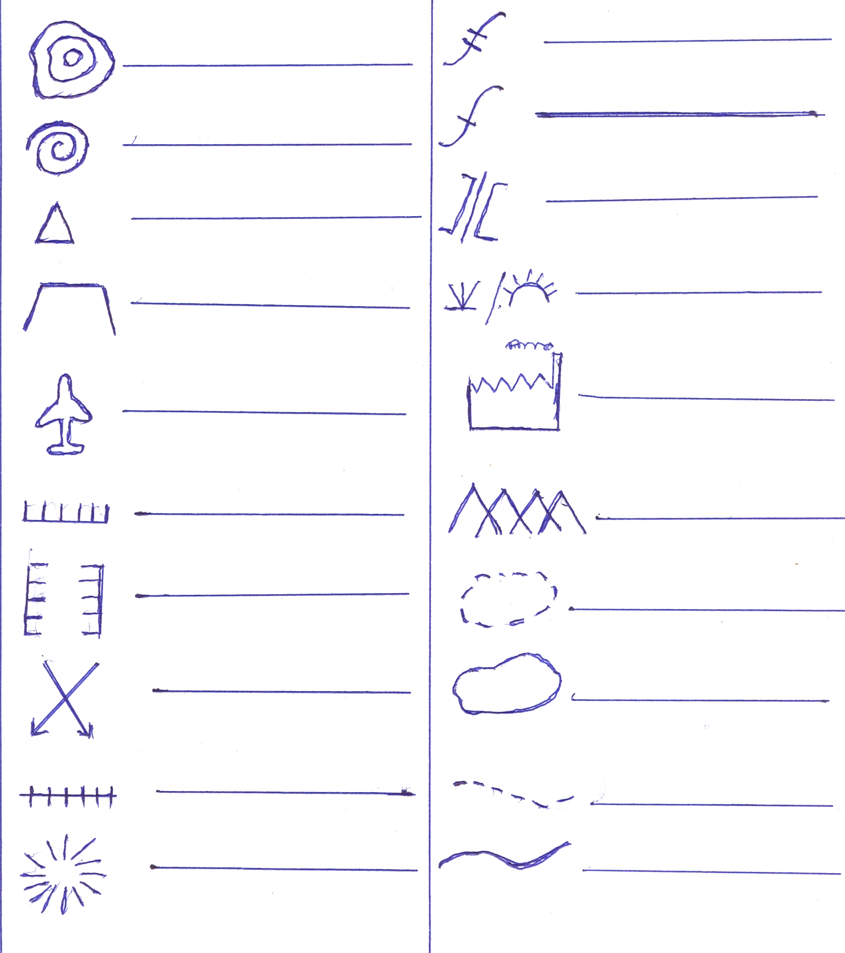

……………………………………………………………………

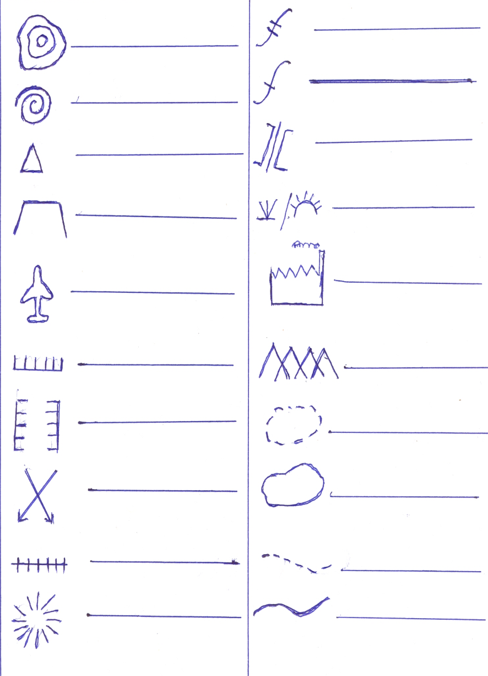

…………………………………………………………………

1. Why are symbols used on maps?

…………………………………………………………………………………………………………………………

1. Draw a map symbol for a bridge.
   * + 1. a) Give **two** ways land is important to people.
2. …………………………………………………………………………………………………………………
3. …………………………………………………………………………………………………………………
4. Mention **two** ways animals are important to people.
5. ………………………………………………………………………………………………………………
6. ………………………………………………………………………………………………………………
   * + 1. **EITHER:**
7. Where did Adam and Eve live?

……………………………………………………………………………………………………………………

1. Name the animal that made Adam and Eve to sin.

……………………………………………………………………………………………………………………

1. Why did Adam and Eve hide from God’s/Allah presence?

……………………………………………………………………………………………………………………

**OR:**

1. Where did Adam and Eve live?

……………………………………………………………………………………………………………………

1. Name the animal that made Adam and Eve to sin.

……………………………………………………………………………………………………………………

1. Why did Adam and Eve hide from God’s/Allah presence?

……………………………………………………………………………………………………………………

* + - 1. **EITHER:**

1. How many days did God take creating the earth.

………………………………………………………………………………………………………………………

1. What did God create first?

………………………………………………………………………………………………………………………

1. What did God create last?

………………………………………………………………………………………………………………………

1. What should people do on the seventh day of the week?

………………………………………………………………………………………………………………………

**OR:**

1. How many days did Allah take creating the earth.

………………………………………………………………………………………………………………………

1. What did Allah create first?

………………………………………………………………………………………………………………………

1. What did Allah create last?

………………………………………………………………………………………………………………………

1. When do Muslims go for Juma prayers?

………………………………………………………………………………………………………………………

* + - 1. **EITHER:**

1. Name the river where Jesus was baptized from.

………………………………………………………………………………………………………………………

1. Mention the person who baptized Jesus Christ.

………………………………………………………………………………………………………………………

1. Write down **two** Christian names.
2. ………………………………………………… ii) …………………………………………………

**OR:**

1. Name the city where Prophet Muhammad was born.

………………………………………………………………………………………………………………………

1. Who was the father of Prophet Muhammad?

………………………………………………………………………………………………………………………

1. Mention **two** Muslim names you know.
2. ……………………………………………………… ii) ………………………………………………
   * + 1. **EITHER:**
3. Name **two** religious leaders in church.
4. ……………………………………………………………………………………………………………
5. ……………………………………………………………………………………………………………
6. Mention **two** duties of religious leaders.
7. ……………………………………………………………………………………………………………
8. ……………………………………………………………………………………………………………

**OR:**

* + - * 1. Name **two** religious leaders in mosque.

1. ………………………………………………………………………………………………………………
2. ………………………………………………………………………………………………………………
   * + - 1. Mention **two** duties of religious leaders
3. ………………………………………………………………………………………………………………
4. ………………………………………………………………………………………………………………
   * + 1. **BOTH:**
5. Write down **two** good things that can make God/Allah happy.
6. ……………………………………………………………………………………………………………
7. ……………………………………………………………………………………………………………
8. What **two** bad things can make God/Allah annoyed
9. ……………………………………………………… ii) ………………………………………………

**\*\*\*\*\*\*END\*\*\*\*\*\***

1. Find the median age of the children. **( 2 marks)**
2. What is their modal age? **( 1 mark)**
3. Workout the mean age of the children. **(2 marks)**
4. The figure below is a cuboid. Use it to answer the questions that follow.

Find the number of vertices in the

**3cm**

figure. **(1 mark)**

**4cm**

**5cm**

1. How many edges 5cm each are in the figure? **(1 mark)**
2. Calculate the total surface area of the figure above. **(2 marks)**
3. Primary seven in Apele primary School has 60 pupils,  of the class are girls and the rest are boys.
4. What is the fraction of boys in the class? **(2 marks)**
5. How many girls are in P.7 class?  **(2 marks)**
6. How many more girls than boys are in the class?  **(2 marks)**
7. A man and a woman share a price of sh. 300,000 between them in the ratio of 1:4 respectively. The woman shares her part between herself, her mother and her daughter in the ratio 3:2:1 respectively.

How much did her mother receive? **(5 marks)**

1. The table below shows David’s expenditure after visiting a market. Study it and fill in the missing information. **(4 marks)**

|  |  |  |
| --- | --- | --- |
| **Item** | **Unit cost** | **Total cost** |
| __________ kg meat | Sh. 10,000 | Sh. 30,000 |
| 3 heaps of 5 tomatoes | Sh. 2000 | Sh. __________ |
| 500 grams of salt | Sh. 1000 per kg | Sh. __________ |
| **Total expenditure** | | Sh. ___________ |

1. David used 2 bank notes each worth sh. 50,000 to pay for his bill.

Workout his balance

**HARSHTON JUNIOR SCHOOL – MBALE**

**TERM ONE HOLIDAY PACKAGE-2023**

**PRIMARY FOUR ENGLISH**

**Pupil’s Name: ……………………………………………………….**

**Read the following instructions carefully:**

1. This paper has two sections A and B

Section A has 40 questions and section B has 15 questions.

1. All working must be done using a blue or black ball point pen or ink. Any work done in pencil other than graphs and diagrams will **not** be marked.
2. Unnecessary changes of work may lead to **loss** of marks.
3. Any **handwriting** that cannot easily be read may lead to loss of marks.
4. Do not fill anything in the boxes indicated: “**For examiners’ Use only”** and those inside the questions paper.

|  |  |  |
| --- | --- | --- |
| **Qn. No.** | **MARKS** | **EXRS No.** |
| **1 – 10** |  |  |
| **11 – 20** |  |  |
| **21 – 30** |  |  |
| **31 – 40** |  |  |
| **41 – 50** |  |  |
| **51 - 52** |  |  |
| **53- 54** |  |  |
| **55** |  |  |
| **TOTAL** |  |  |

**Turn over**

**SECTION A**

**In each of the questions fill in the blank space with a missing letter**.

1. Sch__ol
2. N__ar
3. B__autiful
4. T___ll

**Fill in the blank space with a suitable word**

1. Primary four pupils were __________happy as a king after eating grasshoppers.
2. The boys ________________ playing football now.
3. Sharon always ________________the classroom using a small broom.
4. Mary’s hen laid an ________________in the morning.

**Use the correct form of the given word in the brackets to complete the sentence.**

1. Monica is the most ________________girl in our family**.(beauty)**
2. Our school is ________________to the church than yours **(near)**
3. Daniel’s car was ________________from Dubai **(buy)**
4. Baby Damale has forgotten ________________pen in the Library **(she)**
5. Tom’s hat is made in a ________________shape **(circle)**
6. We bought four _______________from the market yesterday **(orange)**
7. The girls are ________________sweet potatoes **(peel)**

**Arrange the words in alphabetical order**

1. Junction, corner, near, far

……………………………………………………………………………………………………………………………………

1. Beautiful, tall, handsome, ugly

……………………………………………………………………………………………………………………………………

**Give one word for the underlined group of words.**

1. Martha met the teacher at the **place where two roads meet.**

……………………………………………………………………………………………………………………………………

1. She always goes to the **place where children go to learn.**

……………………………………………………………………………………………………………………………………

**Write in full**

1. Don’t ………………………………………………………………
2. Dr.……………………………………………………………………………………
3. Jan……………………………………………………………………………………………

**Use the given words in a sentence to show that you know their meaning**

1. Hut …………………………………………………………………………………………………………………………………
2. Hat ………………………………………………………………………………………………………………………

**Give the plural form of these words**

1. Knife ……………………………………………………………………………………………………………………………………
2. Child ………………………………………………………………………………………………………………………………………
3. Junction ………………………………………………………………………………………………………………………………

**Rewrite the sentences giving the opposite of the underlined words**

1. Moses has a **blunt** knife

………………………………………………………………………………………………………………………………………

1. We have a **big** mango tree at our school

………………………………………………………………………………………………………………………………………

1. Okello is the **tallest** boy in our school

………………………………………………………………………………………………………………………………………

**Re- write the words to form a meaningful sentence**

1. is What the colour of dress her?

………………………………………………………………………………………………………………………………………

1. next to Opio’s home is church the

………………………………………………………………………………………………………………………………………

**Use “much” or “many” to fill in the blank space**

1. Mary brought __________________sugar from the market yesterday.
2. How __________________is a kilogramme of rice ?
3. There are __________________birds in the nest.
4. That dress does not cost __________________ money

**Write the words correctly**

1. luyg ………………………………………………………………………………………………………………………………………
2. xten……………………………………………………………………………………………………………………………
3. nercor……………………………………………………………………………………………………………………………………

**SUB-ECTION II**

**Rewrite the sentences as instructed in the brackets**

1. Joan is smart. Juliana is also smart. **(Join using …..and……..)**

………………………………………………………………………………………………………………………………………

1. The beautiful house belongs to Odongo. **(Rewrite using :….owner……)**

………………………………………………………………………………………………………………………………………

1. Milka likes playing netball more than volleyball (Rewrite the sentence using:………….prefers ……….to ………..)

………………………………………………………………………………………………………………………………………

1. Akello is taller. Muntu is tall. **(Join using: ……….than………..)**

………………………………………………………………………………………………………………………………………

1. He fell sick. He drank contaminated water. **(Join using:….because…….)**

………………………………………………………………………………………………………………………………………

1. She passed the homework. The teacher did not award her.

**(Join using: ….but…….)**

………………………………………………………………………………………………………………………………………

1. There wasn’t any petrol in the tank**.(Rewrite the sentence using …some)**

………………………………………………………………………………………………………………………………………

1. That is the man. His house was destroyed. **(Join using:…….whose………)**

………………………………………………………………………………………………………………………………………

1. Hannah is the woman. She lost her hand bag. (Join using….Who….)

………………………………………………………………………………………………………………………………………

1. Moses is very short. He couldn’t touch the ceiling.

**(Join using: …………too………to……)**

………………………………………………………………………………………………………………………………………

1. Tom is clever. Jeremiah is also clever. **(Join using:……….as……..as……)**

**SECTION B**

1. **Read the story and in full sentences answer the questions about it.**

**JULIUS LOOKS FOR HIS FRIEND**

Julius is ten years old. He has a friend called Geoffrey, who is nine years old. Geoffrey went to Tororo town last Wednesday but he did not come back.

Julius moving up and down in the town looking for his friend. I asked him to describe Geoffrey to me. He told me that Geoffrey is a short dark skinned boy. He is also fat but not fatter than Julius. Both Julius and Geoffrey is a talkative boy. Julius is a wise boy and Geoffrey is also a wise boy .

**Questions**

1. Who is kind?

…………………………………………………………………………………………………………………………………

1. Who of the two boys is shorter?

…………………………………………………………………………………………………………………………………

1. Where did Geoffrey go?

…………………………………………………………………………………………………………………………………

1. How old is Geoffrey?

…………………………………………………………………………………………………………………………………

1. Who of the two boys is talkative?

…………………………………………………………………………………………………………………………………

1. How old is Julius?

…………………………………………………………………………………………………………………………………

1. When did Julius go to Tororo town?

…………………………………………………………………………………………………………………………………

1. Why did Julius go to Tororo town?

…………………………………………………………………………………………………………………………………

1. Who is a short dark skinned boy?

…………………………………………………………………………………………………………………………………

1. Give the opposite of **fat**

…………………………………………………………………………………………………………………………………

1. **Guided composition**

**Use the words in the box to fill in the story.**

It was one ____________________afternoon when we had gone with my elder sister to fetch water from the nearby well. Four __________________me dressed in black suites and ______________gumboots kidnapped my beautiful sister and took her for the reason ___________________known to them.

When I reached ________________, my father and mother asked me where my _________________sister was. I could not explain because I was shading tears and my neck was so stiff that I could not easily be heard. My mother came __________________to me and held me tight. I told her what had __________________and she immediately collapsed.

My father came and gave her first aid and she recovered shortly. When I ___________________my father, being an old man and very wise, he rushed straight to the LCI chairperson who was very ________________and helped us look for my sister.

**kind, ugly, Sunday, brown, closer, beautiful, home, happened, told, best.**

1. **Read the dialogue below and answer the questions about it in full sentences.**

Douglous: Hello Moses, how are you doing?

Moses: I am fine, and you?

Douglous: I am fine too

Moses: What a nice shirt you have put on!

Douglous: This is a very expensive shirt. Only rich men can afford

it. I bought it from the American market.

Moses : So you are a rich man?

Douglous: No, I am a poor boy but my father is a rich man

Moses : I also have a new shirt at home.

Douglous : How does it look?

Moses: It’s brown and short sleeved.

Douglous: How do you feel when you put on?

Moses: I feel very happy whenever I put on my new shirt. I

also look smart in my new shirt.

Douglous: Which book is that you are carrying?

Moses: This is an interesting book of English written by

Mutiya Sam.

Douglous: It must be a useful book, let me hope you will lend it to

me next week

**Questions**

1. Who are holding the dialogue?

………………………………………………………………………………………………………………………………

1. Who talked first in the dialogue?

………………………………………………………………………………………………………………………………

1. Who put on a nice shirt?

………………………………………………………………………………………………………………………………

1. Who can afford that shirt?

………………………………………………………………………………………………………………………………

1. Is Douglous a rich man?

………………………………………………………………………………………………………………………………

1. Who had a new shirt at home?

………………………………………………………………………………………………………………………………

1. How does Moses’ new shirt look like?

………………………………………………………………………………………………………………………………

1. Who looks smart in his new shirt?

………………………………………………………………………………………………………………………………

1. What was Moses carrying?

………………………………………………………………………………………………………………………………

1. What is the opposite of **smart**?

………………………………………………………………………………………………………………………………

1. **AT THE MARKET**

**Nantale went to Seeta Kasujja. She met Mrs. Jane Kasujja selling some food items.**

**The table below shows the quantity and prices of items Mrs. Kasujja Jane was selling. Use it to answer the questions in full sentences.**

|  |  |  |  |  |  |  |
| --- | --- | --- | --- | --- | --- | --- |
| **Items** | **Tomatoes** | **Cabbage** | **Fish** | **Potatoes** | **Banana** | **Mango** |
| **Price per kg** | 1000/= | 1700/= | 45000/= | 1500/= | 3400/= | 800/= |

**Questions**

1. Who went to Seeta market?

…………………………………………………………………………………………………………………………………

1. Who was selling the food items?

…………………………………………………………………………………………………………………………………

1. How much was a kilogramme of potatoes?

…………………………………………………………………………………………………………………………………

1. Which food item was the cheapest?

…………………………………………………………………………………………………………………………………

1. Which food item was the most expensive?

…………………………………………………………………………………………………………………………………

1. How many items was Mrs. Jane Kasujja selling?

…………………………………………………………………………………………………………………………………

1. Which item was cheaper than tomatoes?

…………………………………………………………………………………………………………………………………

1. What is the cost of tomatoes and fish altogether?

…………………………………………………………………………………………………………………………………

1. Write the following in full form
2. Kg

…………………………………………………………………………………………………………………………

1. Shs

…………………………………………………………………………………………………………………………

1. **Write ten correct sentences from the table below**

|  |  |  |  |
| --- | --- | --- | --- |
| The  Kasoma’s | market  boat  school  bus  table  ball  hospital  man  nurse  shop | is | near the river.  across the lake.  behind the hill.  next to the taxi park.  in front of the class.  far from the centre.  after the mosque.  driving in the middle of the road.  opposite to the market. |

1. ………………………………………………………………………………………………………………………………
2. ………………………………………………………………………………………………………………………………
3. ………………………………………………………………………………………………………………………………
4. ………………………………………………………………………………………………………………………………
5. ………………………………………………………………………………………………………………………………
6. ………………………………………………………………………………………………………………………………
7. ………………………………………………………………………………………………………………………………
8. ………………………………………………………………………………………………………………………………
9. ………………………………………………………………………………………………………………………………
10. …………………………………………………………………………………………………………………………